Adventurous Journey
Group Assessor Report

The Adventurous Journey (AJ) Group Assessor Report allows an Adventurous Journey Supervisor and/or Assessor to sign-off on the team’s Practice and Qualifying Journey once, instead of completing it for each individual participant through the ORB.
Please complete the following steps:
1. Pre-report Checklist for AJ Supervisors/  Assessors: | - The AJ Supervisor completes the Practice Journey, and the AJ Assessor completes the Qualifying Journey. One adult may be both the Supervisor and Assessor.  - Each participant will need to upload one assessment for their Practice Journey and one for their Qualifying Journey.
2. Complete Group Assessor Report: | Fill out the Group Assessor Report below. Please note that Adventurous Journey Supervisors/Assessors that complete this form and also receive a digital request from a participant to fill out their assessment should re-connect with the participant to remind them to upload the Assessment you have provided to .
3. Upload form to the Online Record Book: | Once this document is completed by the AJ Supervisor/Assessor, please send it to each participant so they can all upload a copy to their ORB (participant can upload the template on the “I already have my assessment” section). Follow the sequence of pictures below which are from a participant point of view.
 | Figure 1: Participants can go into the PJ or QJ section on the ORB to click on report, and then send for approval.
 | 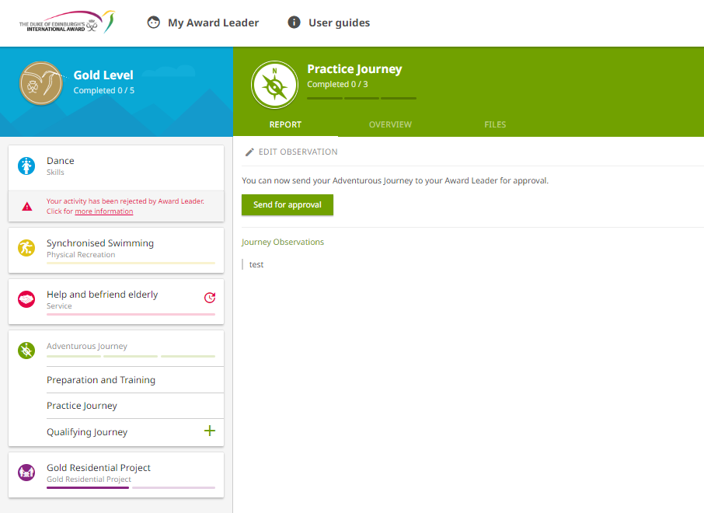
 | Figure 2: Participants will get this pop-up, and can then click on "I already have my assessment". | Figure 3: Participants will get another pop-up where they can attach the Group Assessor Report and then send for approval.
 | 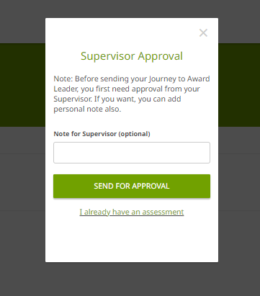 | 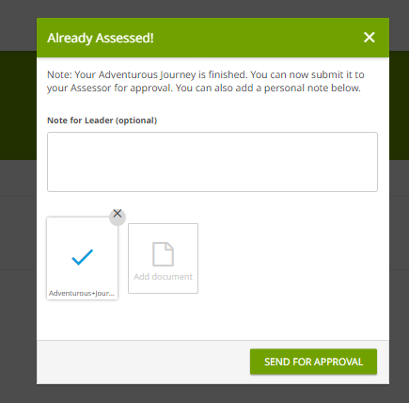

Adventurous Journey Group Assessor Report
Date(s) of Journey:
Award Centre:
Award Leader:
Award Level(s): |  | ☐Bronze |  | ☐Silver |  | ☐Gold
Please select which component of the Adventurous Journey was completed (select one): |  | ☐Practice Journey |  | ☐Qualifying Journey
Please indicate what type of  journey was completed (select one): |  | ☐Practical |  | ☐Virtual
Assessor’s Name:
Date Assessment is Completed:
Assessor’s Qualifications/Experience:
Names of participants on this Journey:
Assessor’s Report: Please provide comments on the improvement, challenge and effort of the group throughout the Journey (if this is an assessment for the Practice Journey, please verify if the group is ready to start their Qualifying Journey).

