**Curriculum & Award Canada**  **Lesson Title:**   **Course:**   **Timeline:**  **Classes:**  **Hours:**

|  |  |  |  |
| --- | --- | --- | --- |
| **Unit:**   * Unit 1: * Unit 2: * Unit 3: * Units 4: | | **Consider All Learners:**   * Multi-Lingual Language Learners * Culturally Responsive Approach * Student and Classroom Needs * Technology * Materials * Resources | **Assessment:**   * FOR Learning (what students already   know and can do e.g. self-assessment)   * AS Learning (Ongoing feedback) * OF Learning (Confirm what students know) |
| **Curricular Outcomes and Expectations:**  Award Canada is a framework adaptable to all curriculum in a personalized approach. | | **Award Framework:**   * Service * Skill Development * Physical Recreation * Adventurous Journey | **Prep NOTES:**   * Teacher completes Level 1 Training * Students register for Award * Review [SMART Goal Award](https://www.dukeofed.org/wp-content/uploads/2024/08/Smart-Goals-Worksheet-1.pdf) resource to support student goal setting. Visit [Activity Zone](https://www.dukeofed.org/award-activity-zone/). * Discuss with students what they know and want to know about future careers. |
| **Provincial Curriculum:** | | **Curriculum Outcomes Through participation in the Award:**   * Portfolio * Student Reflections * Goal Setting * Literacy & Communication * Service – supporting school, community, peers, elementary program related to the curricular subject * Skill – related to a curricular outcome /goal * Physical Recreation – movement goal related to curriculum * Adventurous Journey – overnight fieldtrip related to curriculum /subject | |
| **Focus for Learning** | **Review -** [**How to Write a SMART Goal**](https://www.dukeofed.org/wp-content/uploads/2024/08/Smart-Goals-Worksheet-1.pdf) **worksheet:**  Specific, Measurable, Achievable, Realistic, and Time-bound.  Visit [Activity Zone](https://www.dukeofed.org/award-activity-zone/) for SMART Goal Award Examples. | **Prior Knowledge / Previous Lesson Outcomes**  What do I KNOW? What do I WANT to know? - Prompts to write or connect to SMART Goal | |
|  | Turn curricular “Learning Goals” into “SMART Goals” to support students understanding of the Success Criteria and complete Award Goal setting.  What do they know about careers, hobbies, or interests? What do they want to know? (Need a prompt – try [ChatterHigh](https://resources.chatterhigh.com/question-resources-downloads) free resources for gamified [Career exploration)](https://resources.chatterhigh.com/career-exploration-guide)  **Begin to answer:**  Who am I? What are my opportunities? What are my next steps and why?  What is my action plan? | Support students with SMART statements:  *I want to improve my...*  *I will practice / spend __ times a week/month to achieve ___ ...*  *I will know I have achieved my goal because ...* | |
| **Lesson Sequence** | | **Student Consolidation /Reflection - What did I learn?** | |
| 1. Students register for the Award, Review Portfolio Development Certification through Online Record Book 2. Review how to set a SMART goal 3. Set SMART goals for each section of the Award framework: Service, Skill, Physical Recreation    1. [Adventurous Journey](https://www.dukeofed.org/adventurous-journey-navigator/) is a collaborative goal 4. Students reflect on their learning in each section of the Award (Service, Skill, Physical Recreation, Adventurous Journey) in the Online Record Book.    1. Use student reflections as a self-assessment, assessment as learning and for learning.    2. Include reflections to build student portfolio and understanding of learning goals. | | Students reflect on their learning in each section of the Award (Service, Skill, Physical Recreation, Adventurous Journey) in the Online Record Book.  Educators may have reflections happen daily, weekly or monthly.  What did I learn?  What did I learn about myself?  What will I do next? | |

**Get to know your student’s interests to establish an Award focus.**

Select [Appendix F2](https://www.gov.nl.ca/education/files/k12_curriculum_guides_english_english1201cg2017.pdf) below (Taken from page 109 of the English 1201 Newfoundland Curriculum guide) to explore your focus and interests. This will help you get started in planning and setting your SMART goals.

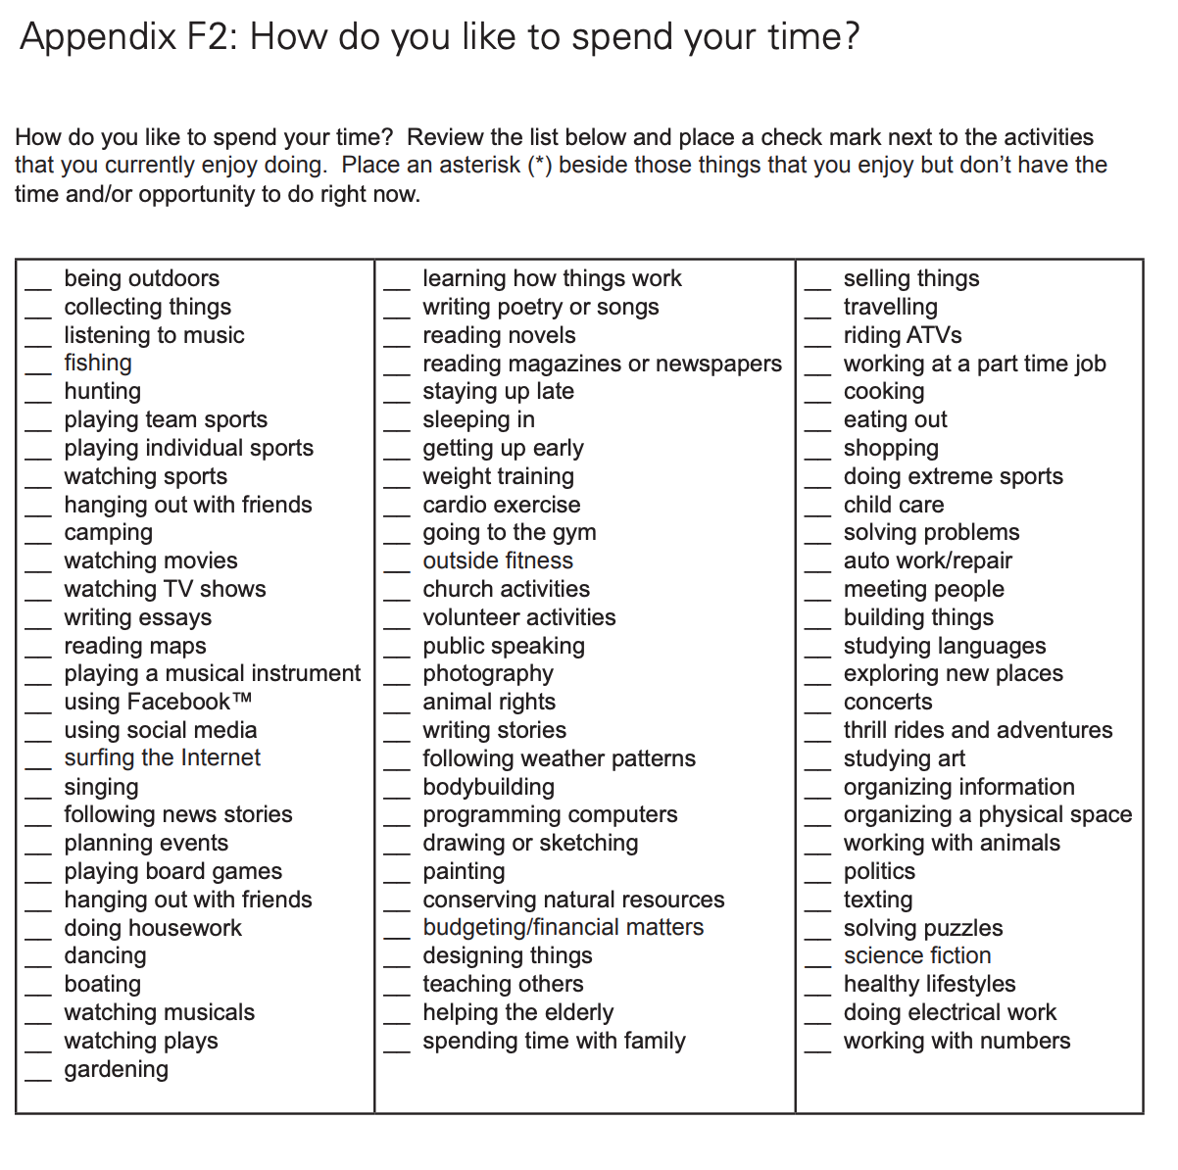

Students will use their selection focus to support the development of their individual SMART goals. Here is a worksheet to help you get started: [SMART Goal Worksheet](https://www.dukeofed.org/wp-content/uploads/2024/08/Smart-Goals-Worksheet-1.pdf)