**NL Curriculum & Award Canada**  **Lesson Title: Award & Functional Programming**   **Course:** [Alternate Curriculum](https://www.gov.nl.ca/education/files/k12_studentsupportservices_publications_functionalcurriculumguide.pdf) **# Classes:**

|  |  |  |  |
| --- | --- | --- | --- |
| **Curricular Guide:**  **X Career Development Domain**   * **Personal Development, Interpersonal Skills Domain** * **Independent Living Domain** * **Functional Academics Domain**   Using the Award framework students can personalize programming based on individual needs. | | **Consider All Learners:**   * Multi-Lingual Language Learners * Culturally Responsive Approach   X Student and Classroom Needs   * Technology * Materials * Resources | **Assessment:**   * FOR Learning (what students already   know and can do e.g. self-assessment)  X AS Learning (Ongoing feedback)   * OF Learning (Confirm what students know) |
| **Curricular Outcomes and Expectations:**   * Money and Money Management * Decision Making * Goal Setting * Conflict Resolution * Change and Growth   Each section of the Award requires students to set a personal goal and reflect on their experiences, growth and process. | | **Award Framework:**  X Service  X Skill Development  Physical Recreation  Adventurous Journey  All aspects of the Award provide opportunities to plan, communicate and reflect. | **Prep Notes:**   * Teacher completes Level 1 Training * Students & parents register for Award * Review [SMART Goal Award resource](https://www.dukeofed.org/wp-content/uploads/2024/08/Smart-Goals-Worksheet-1.pdf) to support student goal setting and curriculum [Appendix F2, pg. 109](https://www.gov.nl.ca/education/files/k12_curriculum_guides_english_english1201cg2017.pdf) * Students use the Award goals and reflection to log and track their progress. |
| **Functional Curriculum:**  Students who access a functional curriculum are identified as having moderate, severe or profound impairments in cognition and severe deficits in adaptive functioning as evaluated through the comprehensive assessment process.  Career education should be considered learning for life rather than learning for school. It ought  to be a planned process, designed and delivered in a holistic rather than fragmented manner that  attends to all needs of the individual with the aim to facilitate good mental health, as well as  economic well-being.  The purpose of the career exploration and awareness strand is to enable students to develop an awareness of the career options available to them and the opportunity to explore these options. In addition, students will develop career related skills. | | **Curriculum Outcomes Through participation in the Award**  **SMART** Goal Setting Using Award Framework   demonstrate an understanding of task commitment   access support to develop personal goals   be aware of available jobs which match specific interests and goals  **Service (Award Framework)**   * Understand the difference between paid and unpaid work experience * Identify opportunities within their community or school * Access support from family and community   **Skill Development (Award Framework)**   * Resume Development * Gain Work experience   See appendix and curriculum for examples. | |
| **Focus for Learning** | **Review -** [**How to Write a SMART Goal**](https://www.dukeofed.org/wp-content/uploads/2024/08/Smart-Goals-Worksheet-1.pdf) **worksheet:**  Specific, Measurable, Achievable, Realistic, and Time-bound.  Visit [Activity Zone](https://www.dukeofed.org/award-activity-zone/) for SMART Goal Award Examples | **Prior Knowledge / Previous Lesson Outcomes**  What do I KNOW? What do I WANT to know? - Prompts to write or connect to SMART Goal | |
| An educational program that provides pro-active strategies to enable an individual to build on their strengths, anticipate their needs and preferences is an effective model to facilitate an individual’s inclusion into school and community settings.  Career exploration and awareness includes themes such as money and money management, decision making, goal setting, conflict resolution, change and growth. Several functional skills outcomes for this strand are listed in the table below. | Turn curricular “Learning Goals” into “SMART Goals” to support students understanding of the Success Criteria and complete Award Goal setting.  What do they Know about careers, hobbies, or interests?  What do they want to know?  Who am I?  What are my opportunities and abilities?  What are my next steps and why?  What is my action plan? | Understand student interests and abilities to support Service and Skill Development goal.  Are they involved in activities within the school and community that can align with Career Development goals? Use the Award to support the organization and celebration of their progress. | |
| **Lesson Sequence** | | **Student Consolidation /Reflection - What did I learn?** | |
| 1. Students register for the Award, Review Portfolio Development Certification through Online Record Book 2. Review how to set a SMART goal 3. Develop a Personal Career Plan - Set SMART goals for each section of the Award framework: Service, Skill, Physical Recreation    1. [Adventurous Journey](https://www.dukeofed.org/adventurous-journey-navigator/) is a collaborative goal 4. Students reflect on their learning in each section of the Award (Service, Skill, Physical Recreation, Adventurous Journey) in the Online Record Book.    1. Students use the Award goals and reflection to log and track their progress. | | You may have reflections happen daily, weekly or monthly.  What did I learn?  What did I learn about myself?  What will I do next? | |

**Below is a resource to get to know your student’s interests to establish an Award focus.**

Select [Appendix F2](https://www.gov.nl.ca/education/files/k12_curriculum_guides_english_english1201cg2017.pdf) below (or found on page 109 of the English 1201 curriculum guide) to explore your focus and interests. This will help you get started in planning and setting your SMART goals.

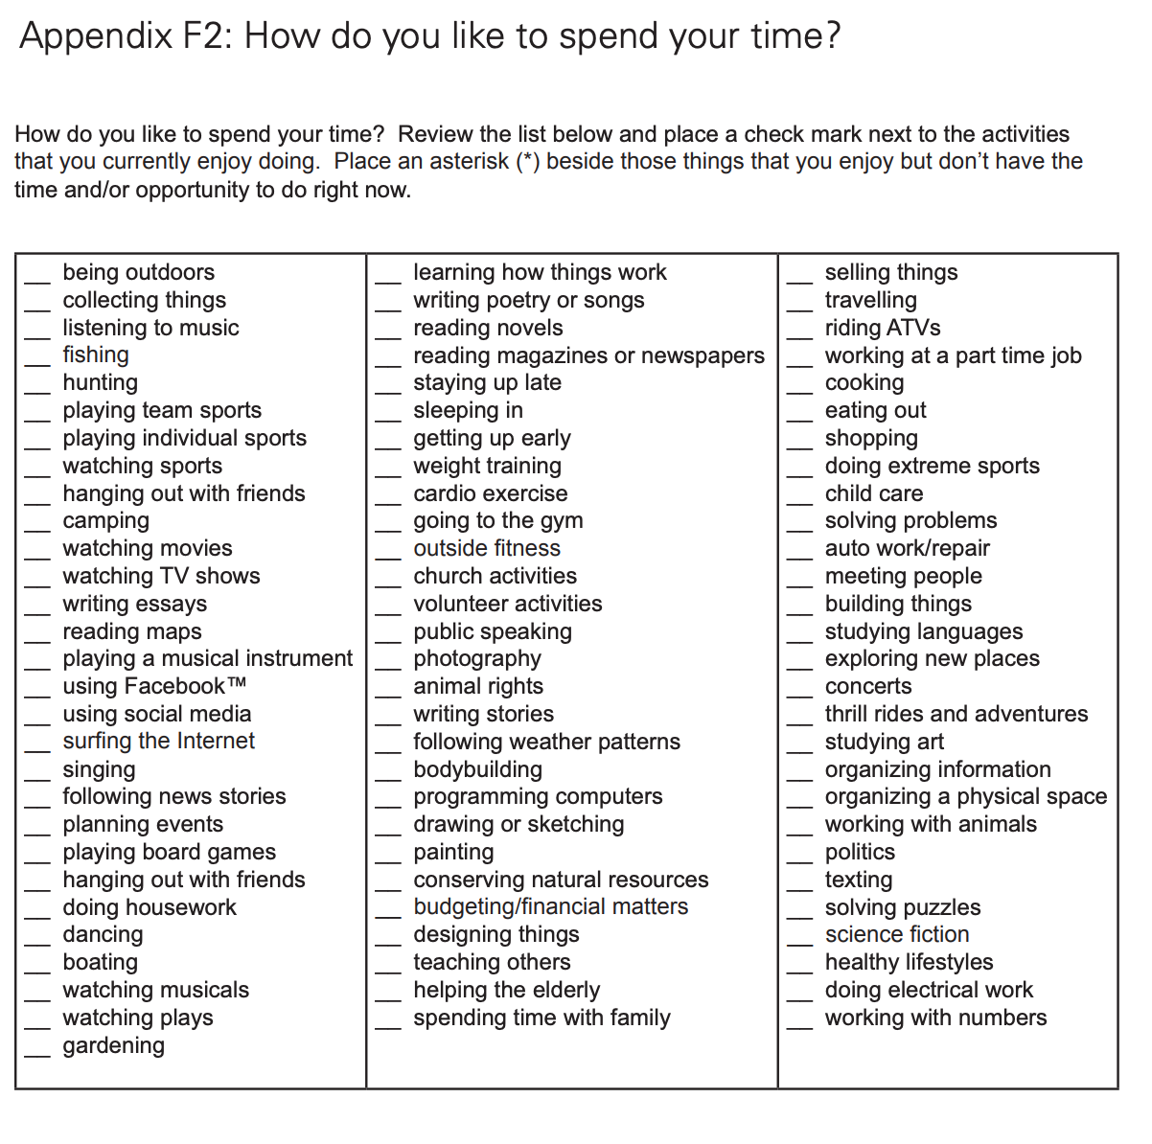

Students will use their selection focus to support the development of their individual SMART goals. Here is a worksheet to help you get started: [SMART Goal Worksheet](https://www.dukeofed.org/wp-content/uploads/2024/08/Smart-Goals-Worksheet-1.pdf)