**Curriculum & Award Canada**  **Lesson Title:** [Personal Management](https://www.gov.nl.ca/education/files/career_education_2202_final_july_2021.pdf)  **Course:** [Career](https://www.gov.nl.ca/education/files/career_education_2202_final_july_2021.pdf) **Timeline: Classes: Hours:**

|  |  |  |  |
| --- | --- | --- | --- |
| **Unit:**  X Unit 1: Personal Management   * Unit 2: Financial Literacy * Unit 3: Life/Work Exploration and Employability Skills * Units 4: Preparing for Life/Work Transitions | | **Consider All Learners:**   * Multi-Lingual Language Learners * Culturally Responsive Approach * Student and Classroom Needs * Technology * Materials * Resources | **Assessment:**  X FOR Learning (what students already  know and can do e.g. self-assessment)  X AS Learning (Ongoing feedback)   * OF Learning (Confirm what students know) |
| **Curricular Outcomes and Expectations:**  Key topics include the setup and organization of the Personal Career Plan (PCP), decision-making, goal setting, and health and wellness. Personal Management curricular expectations can be achieved by integrating the Award within class time, assessment strategies and personal student approach. | | **Award Framework:**  X Service  X Skill Development  X Physical Recreation   * Adventurous Journey | **Prep NOTES:**   * Teacher completes Level 1 Training * Students register for Award & parent approval * Review [SMART Goal Award](https://www.dukeofed.org/wp-content/uploads/2024/08/Smart-Goals-Worksheet-1.pdf) resource to support student goal setting. Visit [Activity Zone](https://www.dukeofed.org/award-activity-zone/). * Discuss with students what they know and want to know about future careers. * Portfolio Development Certification |
| **Newfoundland Career Curriculum:**  GCO 1: **Self Awareness & Positive Interaction** - Students will be expected to enhance their knowledge of strategies for building and maintaining a positive self-image and understand its influence on building positive relationships in one’s life and work.  GCO 2: **Change** - Students will be expected to learn to respond to change and growth in their life/work.  GCO 3: **Life-long Learning** - Students will be expected to link learning to one’s career building process.  GCO 6: **Life/work roles** - Students will be expected to link lifestyles, life role and life stages to life / work building while understanding and overcoming stereotypes/bias in life and work.  GCO 7: **Decision making** - Students will be expected to engage in life/work decision making.  GCO 8: **Independent management of life/work building process** - Students will be expected to recognize and take charge of their own life/work building process.  **Outcomes**  2.0 identify the **concept of career development** [GCO 1]  3.0 analyze the **complexity of career development** [GCO 1]  4.0 explore self-awareness of **personal management skills** [GCO 1, 3]  5.0 demonstrate effective **decision making** and **goal setting** [GCO 1, 7]  6.0 recognize how **health and wellness** can impact careers [GCO 2, 6]  7.0 develop strategies to achieve a **positive life/work balance** [GCO 2, 6] | | **Provincial Curriculum Outcomes Through participation in the Award:**  1.0 develop and maintain a Personal Career Plan (PCP) [GCO 8] by completing the **Award framework**.  2.0 identify the concept of career development [GCO 1], • Connect their own interests with those of the community. Discuss how they can earn eligible career development hours based on personal interests – through Award goals and reflection of meaningful **Service**  3.0 analyze the complexity of career development [GCO 1] to answer Who am I? What are my opportunities? What are my next steps and why? What is my action plan?... Award **Skill:** students investigate career interests to set a goal in learning a new skill related to career of interest and/or make “career exploration” their skill focus. For example, please visit Award: [Test Drive Your Career,](https://www.dukeofed.org/test-drive-your-career/) and the [Activity Zone](https://www.dukeofed.org/award-activity-zone/) to explore Goal Setting examples and prompts in a range of industry sectors.  **Award +** GCO2 – students reflect in the Award on experiences and their learning or growth from those experiences.  4.0 explore self-awareness of personal management skills [GCO 1, 3] - Compose a summary of what you have learned about yourself in every **Award Reflection Log in the Online Record Book.**  **Award +** GCO3 – students set SMART goals in one or more sections of the Award that are relevant to their personal interests and career building goals.  5.0 demonstrate effective decision making and goal setting [GCO 1, 7] using two major criteria: • SMART (Specific, Measurable, Achievable/Attainable, Realistic/ Relevant, Timely) • Timeframe - Short/medium/long term through the Award Framework SMART goal process.  6.0 recognize how health and wellness can impact careers [GCO 2, 6] - set a health goal in Physical Recreation or Skill to improve your well-being. For example, visit the Government of [Canada Canadian Centre for Occupational Health and Safety](https://www.ccohs.ca/topics/wellness), Health and Wellness to set a Skill Development goal to learn about Mental Health, Stress, Bullying, Work-Life Balance and more. Build on your learning by taking action to address your Skill Development, or setting a goal in a Physical Activity, such as yoga, walking, or a sport.  7.0 develop strategies to achieve a positive life/work balance [GCO 2, 6] - create a **Physical Recreation** goal and reflect on the impact active living can have on lives, stress, and healthy balance. | |
| **Focus for Learning** | [**How to Write a SMART Goal**](https://www.dukeofed.org/wp-content/uploads/2024/08/Smart-Goals-Worksheet-1.pdf) **worksheet:**  Visit [Activity Zone](https://www.dukeofed.org/award-activity-zone/) for SMART Goal Award Examples | **Prior Knowledge / Previous Lesson Outcomes**  What do I KNOW? What do I WANT to know? - Prompts to write or connect to SMART Goal | |
| Goal setting enables an individual to reflect on ‘where do I go from here?’ It provides long term vision and helps keep one focused, motivated and committed. Setting goals provides an individual with a step-by-step plan, allowing for the measuring of progress and refinement along the way.  Learners integrate their family, school, work and community learning experiences, and their personal characteristics, to guide good work and life choices  Self-awareness refers to an understanding of one’s individuality, including personality, emotional development, multiple intelligences, attitudes, beliefs, aptitudes, interests, values and how these influence their career choices.  Students should have an awareness of the importance of health and wellness in their lives and the importance of solid support networks. | Turn curricular “Learning Goals” into “SMART Goals” to support students understanding of the Success Criteria and complete Award Goal setting.  What do they Know about careers, hobbies, or interests? What do they want to know?  **Tools to support the exploration of career interests:**   * Survey chart below Appendix F2   **Begin to answer:**  Who am I?  What are my opportunities?  What are my next steps and why?  What is my action plan? | Support students with SMART statements:  *I want to improve my...*  *I will practice / spend __ times a week/month to achieve ___ ...*  *I will know I have achieved my goal because ...*  If interested in a specific career, what are my next steps to learn about pathways in that career? (Include in your Award SMART goal).  If students do not know what they are interested in, start with the prompt chart. The quiz asks them to explore and discover various careers to narrow down their interest. | |
| **Lesson Sequence** | | **Student Consolidation /Reflection - What did I learn?** | |
| 1. Students register for the Award 2. Parents Approve Participation 3. Review how to set a [SMART goal Worksheet](https://www.dukeofed.org/wp-content/uploads/2024/08/Smart-Goals-Worksheet-1.pdf)    1. Their **Skill Development** component could be building their “Career Development” knowledge and the steps they will take to expand their career pathway understanding OR their Skill Development could be specific to their Career of interest. 4. Students complete a Portfolio Development Certification through the set-up of the Online Record Book.   [Print Certificate Here.](https://www.dukeofed.org/wp-content/uploads/2024/12/Portfolio-Development-Certificate.pdf) Have students to add the Award Canada Portfolio Certification to their resumes.   1. Develop a Personal Career Plan - Set SMART goals for each section of the Award framework: Service, Skill, Physical Recreation    1. [Adventurous Journey](https://www.dukeofed.org/adventurous-journey-navigator/) is a collaborative goal 2. Students reflect on their learning in each section of the Award (Service, Skill, Physical Recreation, Adventurous Journey) in the Online Record Book.    1. Educator uses reflections as assessment as learning and for learning | | Students reflect on their learning in each section of the Award (Service, Skill, Physical Recreation, Adventurous Journey) in the Online Record Book. You may have reflections happen daily, weekly or monthly.  What did I learn?  What did I learn about myself?  What will I do next? | |

**Get to know your student’s interests to establish an Award focus.**

Select [Appendix F2](https://www.gov.nl.ca/education/files/k12_curriculum_guides_english_english1201cg2017.pdf) below (or found on page 109 of the English 1201 curriculum guide) to explore your focus and interests. This will help you get started in planning and setting your SMART goals.

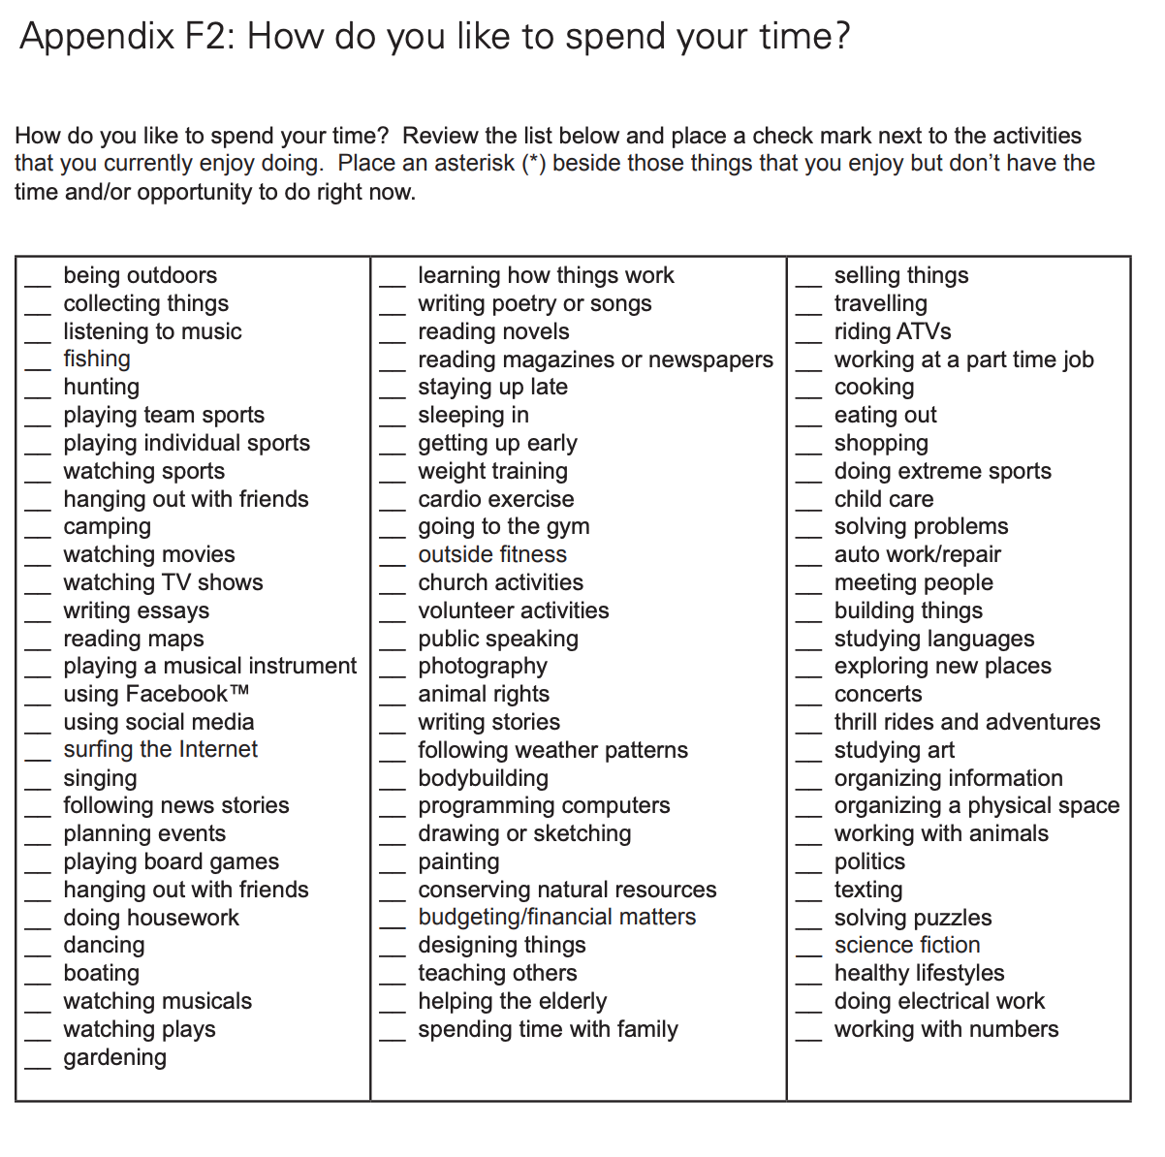

Students will use their selection focus to support the development of their individual SMART goals. Here is a worksheet to help you get started: [SMART Goal Worksheet](https://www.dukeofed.org/wp-content/uploads/2024/08/Smart-Goals-Worksheet-1.pdf)