**NL Curriculum & Award Canada**  **Lesson Title:**  Writing and Representing **Course:** [English 1201 (Gr.10)](https://www.gov.nl.ca/education/files/k12_curriculum_guides_english_english1201cg2017.pdf)  **# Classes:**

|  |  |  |  |
| --- | --- | --- | --- |
| **General Curricular Outcomes (GCO)**   * Speaking and Listening (GCO1, 2, 3) * Reading and Viewing (GCO 4, 5, 6, 7)   **X Writing and Representing (GCO 8, 9, 10)**  Writing and Representing involves multiple, simultaneous processes, including but not limited to: activating and connecting to prior knowledge, ideas, and experiences, generating and composing imagined ideas, recreating and consolidating information from a variety of sources.  Using the Award framework students can personalize their writing, ideas, and understanding from multiple experiences and sources. | | **Consider All Learners:**   * Multi-Lingual Language Learners * Culturally Responsive Approach * Student and Classroom Needs * Technology * Materials * Resources | **Assessment:**   * FOR Learning (what students already   know and can do e.g. self-assessment)  X AS Learning (Ongoing feedback)  X OF Learning (Confirm what students know) |
| **Curricular Outcomes and Expectations:**  In writing and representing, students must decode, understand, evaluate, and create a variety of forms and reflect on the creation process.  Each section of the Award requires students to set and understand their goals, evaluate and reflect on their experiences, growth and process. Literacy is built into a personalized, non-competitive approach. | | **Award Framework:**  X Service  X Skill Development  X Physical Recreation  X Adventurous Journey  All aspects of the Award provide opportunities to plan, communicate and reflect. | **Prep Notes:**   * Teacher completes Level 1 Training * Students register for Award * Review [SMART Goal Award resource](https://www.dukeofed.org/wp-content/uploads/2024/08/Smart-Goals-Worksheet-1.pdf) to support student goal setting and curriculum [Appendix F2, pg. 109](https://www.gov.nl.ca/education/files/k12_curriculum_guides_english_english1201cg2017.pdf) * Discuss with students how they can write, reflect, communicate, learn and experience topics of interest to them while in English. * Use the Award to log and assess learning to make English feel personalized and relevant. * Students use the Award goals and reflection to log and track their inquiry process. |
| **Curriculum: Writing and Representing**  GCO8: Students will be expected to use writing and other forms of representation to explore, clarify, and reflect on their thoughts, feelings, experiences, and learnings; and to use their imaginations.  GCO 9: Students will be expected to create texts collaboratively and independently, using a variety of forms for a range of audiences and purposes.  GCO 10: Students will be expected to use a range of strategies to develop effective writing and representing and to enhance their clarity, precision, and effectiveness. | | **Curriculum Outcomes Through participation in the Award**  GCO8: Reflect on their thoughts, feelings, experiences, and learnings in an organized and consistent manner through all stages of the Award Framework. Experiences can be outside of English class; however, the planning and reflections happen as part of the curriculum. For example, supporting an elementary class to write a short story, then reflect on that leadership experience (Service or Skill).  GCO 9: Students will be expected to create texts collaboratively and independently, using a variety of forms for a range of audiences and purposes. Co-design a project management approach to research, prepare, plan and reflect on the [Adventurous Journey](https://www.dukeofed.org/adventurous-journey-navigator/). Brainstorm, divide roles, share learning and make collaborative decisions.  GCO10: Use a range of strategies to develop effective writing and representing and to enhance their clarity, precision, and effectiveness. For example, for the Award framework “Service” component, might involve students working or mentoring an elementary school partner to write a short story. Through this process, they explain their approach with precision.  Another example could be to teach a business how to improve their social media presence, what the goals are, clarity of the message and impact. | |
| **Focus for Learning** | **Review -** [**How to Write a SMART Goal**](https://www.dukeofed.org/wp-content/uploads/2024/08/Smart-Goals-Worksheet-1.pdf) **worksheet:**  Specific, Measurable, Achievable, Realistic, and Time-bound.  Visit [Activity Zone](https://www.dukeofed.org/award-activity-zone/) for SMART Goal Award Examples | **Prior Knowledge / Previous Lesson Outcomes**  What do I KNOW? What do I WANT to know? - Prompts to write or connect to SMART Goal | |
| Writing and representing allow students to express themselves and communicate ideas by creating a variety of media and diverse texts.  In English 1201, they should continue to have multiple opportunities to write and represent. They will continue to develop skills and confidence in writing and representing by creating a variety of texts that are personal and creative.   * activating and connecting to prior knowledge, ideas, and experiences * generating and composing imagined ideas * recreating and consolidating information from a variety of sources | Turn curricular “Learning Goals” into “SMART Goals” to support students understanding of the Success Criteria and complete Award Goal setting.  What do they Know about careers, hobbies, or interests?  What do they want to know?  **Creating Text:**  Who am I?  What are my opportunities?  What are my next steps and why?  What is my action plan?  **I can:**  create a journal response on a topic, issue, or idea  create questions on a topic, issue, or idea  describe a time when I was involved in . . . (something similar)  summarize my prior knowledge on the topic  preview illustrations, graphs, glossary, table of contents, titles, and other text features | **Support students with SMART statements:**  *I want to improve my...*  *I will practice / spend __ times a week/month to achieve ___ ...*  *I will know I have achieved my goal because ...*  ***Using Language Features:***  *How will your audience know about your personal interest in the topic?*  *How has the organization of this piece of research helped the readers understand your message and information?*  *What evidence is there in your conclusion to support your viewpoint?*  *What information about this form and genre can help you organize your writing?*  **If you notice a student’s writing:**  *is not focused - support with the SMART goal template.*  *lacks organization - use the Award reflection as a structured literacy routine.*  *mechanical errors – use the Award AI bot on the website or ChatGPT to model effective writing, and review.* | |
| **Lesson Sequence** | | **Student Consolidation /Reflection - What did I learn?** | |
| 1. Students register for the Award, Review Portfolio Development Certification through Online Record Book 2. Review how to set a SMART goal 3. Develop a Personal Career Plan - Set SMART goals for each section of the Award framework: Service, Skill, Physical Recreation    1. [Adventurous Journey](https://www.dukeofed.org/adventurous-journey-navigator/) is a collaborative goal 4. Students reflect on their learning in each section of the Award (Service, Skill, Physical Recreation, Adventurous Journey) in the Online Record Book.    1. Educator uses reflections as assessment as learning and for learning    2. Students use the Award goals and reflection to log and track their inquiry process. 5. It is often difficult for students to evaluate the values and attitudes found within their own writing and representing. To encourage self-evaluation, teachers may provide the following prompts:   1. What values/attitudes are evident?  2. How do I know? What evidence is presented?  3. Is the text form the best choice to represent these values/attitudes? | | Students reflect on their learning in each section of the Award (Service, Skill, Physical Recreation, Adventurous Journey) in the Online Record Book.  You may have reflections happen daily, weekly or monthly.  What did I learn?  What did I learn about myself?  What will I do next? | |

**Get to know your student’s interests to establish an Award and English focus.**

Select [Appendix F2](https://www.gov.nl.ca/education/files/k12_curriculum_guides_english_english1201cg2017.pdf) below (or found on page 109 of the English 1201 curriculum guide) to explore your focus and interests. This will help you get started in planning and setting your SMART goals.

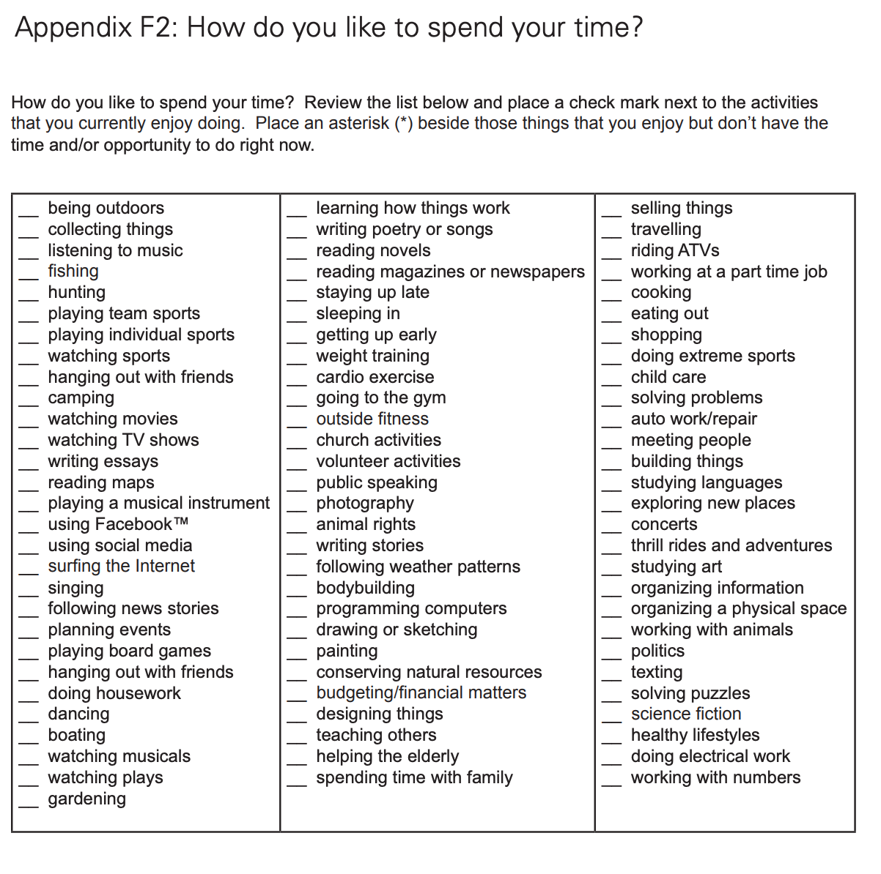

Students will use their selection focus to support the development of their individual SMART goals. Here is a worksheet to help you get started: [SMART Goal Worksheet](https://www.dukeofed.org/wp-content/uploads/2024/08/Smart-Goals-Worksheet-1.pdf)

**Appendix G: Stages of Inquiry (page 110)**

Students use the Award goals and reflection to log and track their inquiry process.

Inquiry involves many different skills and strategies, grouped within stages. As a result of students’

discovery of new information or as new questions arise, these stages can be revisited.

**Planning**

Planning for inquiry provides the foundation on which a successful project is created.

Steps include:

1. Students and teachers decide on a general topic or problem that requires further exploration.

2. The topic or problem is narrowed. Students write a research thesis and develop questions.

3. Students list key words or ideas related to the research questions and subtopics that they will use.

4. Students prepare a list of sources they will use.

5. Methods for recording information and materials are used.

**Gathering Information**

Students search for meaning and understanding as they access appropriate learning resources. They:

• find and use resources from outside the school

• generate a variety of research terms to locate information

• identify and use appendices and bibliographies as sources

• locate information from multiple primary and secondary sources to ensure accuracy

• locate information using cross references and links

**Interacting with Information**

Students evaluate information to determine if it will be useful in answering their questions. They:

• extract relevant information and record information needed to answer their guiding questions

• make notes using an idea web, matrix sheet, chart and computer database, spreadsheet, etc.

• record bibliographic information, including the names of resource persons and dates of interviews

• skim, scan, view, and listen to critically evaluate whether the content is relevant to the topic

**Synthesizing Information**

Students need to take information from a variety of sources and synthesize it in a unique and personal way to meet their inquiry question.

They use a variety of strategies such as:

• understanding the rules of copyright and plagiarism

• numbering, sequencing, or highlighting notes to organize the information

• presenting their product/presentation in a way that is meaningful for a particular audience

• reviewing information to determine whether they need more facts or further clarification

**Assessment and Evaluation**

Emphasis is on involving the student in the assessment of the process as well as the product. Students can evaluate their own products/presentations and those of peers by:

• asking questions, making observations, and participating in discussions throughout the process – ongoing growth and development through the Award framework

• creating portfolios as evidence of developing information literacy – progression through the student’s Award goals and reflections can be used as the portfolio

• knowing the evaluation scheme prior to beginning -

• using teacher-made, student-made or co-constructed evaluation charts or rubrics – explain the Award and expectations to complete stages each month