**Curriculum & Award Canada** **Lesson Title:**  Career Gr. 9 or 10 Classes: Semester to Complete Bronze Hours: (4 hours month per section)

|  |  |  |  |
| --- | --- | --- | --- |
| **Goals**  Award Canada is a framework adaptable to all curriculum in a personalized approach. This course gives students the opportunity to develop the skills, knowledge, and habits that will support them in their education and career/life planning.  **All students will develop career management competencies through an exploration of personal change and growth**  - Plan for, demonstrate, and document improvements of one’s own capacity for building a positive self-image.  - Appraise one’s own abilities to respond positively to change and growth.  **All students will explore the connections between learning and work pathways and their connections to community**   * Utilize career information to construct an organized plan of career building which reflects an attitude and expectation of lifelong learning * Analyze and express one’s own understanding of how societal and economic needs influence the nature of paid and unpaid work   **All students will engage in inquiry to construct a personal work and life plan**   * Assess one’s own abilities to seek, obtain, and/ or create work through researching successful strategies and applying them to ones’ own life * Use acquired knowledge to create a plan for life and work based on one’s preferred future | |  | **Assessment:**   * FOR Learning (what students already   know and can do e.g. self-assessment)   * AS Learning (Ongoing feedback) * OF Learning (Confirm what students know) |
| **Award Framework:**   * Service * Skill Development * Physical Recreation * Adventurous Journey | **Prep NOTES:**   * Teacher completes Level 1 Training * Students register for Award * Review [SMART Goal Award](https://www.dukeofed.org/wp-content/uploads/2024/08/Smart-Goals-Worksheet-1.pdf) resource to support student goal setting. Visit [Activity Zone](https://www.dukeofed.org/award-activity-zone/). * Discuss with students what they know and want to know about future careers. * Identify areas of interest to begin goal setting in Online Record Book or ORB App |
| **Provincial Broad Areas of Learning:**  Career Education contributes to the Goals of Education through helping students achieve knowledge, skills, and attitudes related to these Broad Areas of Learning.   * **Career 10 – Personal Growth, Career Pathways, Goal setting, Transferable Skills, Well-being, Community & Citizenship**   + *Develops self-awareness by exploring interests, strengths, values, and skills*   + *Identifies personal attributes and how they connect to future goals*   + *Research career clusters and pathways (apprenticeship, trades, university, entrepreneurship, etc.)*   + *Explores labour market information and future trends*   + *Sets SMART goals for personal, academic, and career development*   + *Develops action plans to achieve them*   + *Builds communication, teamwork, problem-solving, adaptability*   + *Explores essential workplace skills (e.g., collaboration, leadership, initiative)*   + *Develops strategies for maintaining balance, well-being, and adaptability in career/life planning* | | **Career Outcomes Through participation in the Award:**   * Portfolio – Skills, Interests, and Values * Student Reflective Practice * SMART Goal Setting and Decision Making * Literacy & Communication * Service – supporting school, community, peers, elementary program related to the curricular subject * Skill – Career Exploration, Market Trends, and Pathway Planning and Financial Management * Physical Recreation – Work Life Balance and Well-Being * Adventurous Journey – overnight fieldtrip related to competencies and/or career of interest | |
| **Focus for Learning** | **Review -** [**How to Write a SMART Goal**](https://www.dukeofed.org/wp-content/uploads/2024/08/Smart-Goals-Worksheet-1.pdf) **worksheet:**  Specific, Measurable, Achievable, Realistic, and Time-bound.  Visit [Activity Zone](https://www.dukeofed.org/award-activity-zone/) for SMART Goal Award Examples. | **Prior Knowledge / Previous Lesson Outcomes**  What do I KNOW? What do I WANT to know? - Prompts to write or connect to SMART Goal | |
| Use the Award framework as your portfolio/communication tool to share your story and meet curricular expectations.    Students use the Award as the process of career exploration, reflection, personal development, and real-world application. | Start your “SMART Goals” to support students understanding of the Success Criteria and complete Award Goal setting.  What are my personal interests and goals? Why is it important to evaluate my interests? What steps can I take to explore my interests and track my progress? Why and where can this take me?    What have I learned about myself and future choices?  What do they know about careers, hobbies, or interests?  What do they want to know?  **Begin to answer:**  Who am I? What are my opportunities? What are my next steps and why?  What is my action plan? | Support students with SMART statements:  *I want to improve my...*  *I will practice / spend __ times a week/month to achieve ___ ...*  *I will know I have achieved my goal because ...* | |
| **VOLUNTARY SERVICE:**   * How can you find out about mentorship, part-time work, or volunteer opportunities in your community? What areas are service would be meaningful to you? Set a goal and reflect on your Service experiences.   **SKILL DEVELOPMENT**  Set a goal to learn about careers and pathways meaningful to you.   * Use the Award to develop a personal profile based on an exploration of their interests, values, skills, strengths, and needs, and examine the range of factors that can influence their future education and career/life opportunities. * In your SMART personal goal, include opportunities to research postsecondary options.   **PHYSICAL RECREATION**   * Set goal to improve your fitness to achieve a healthy school/life/work balance and well-being. How does physical recreation impact your future career success?   **ADVENTUROUS JOURNEY**   * Develop a project management plan to stay overnight in an area relevant to your interests and career growth. * Demonstrate an understanding of responsible management of financial resources and of services available to support their financial literacy as they prepare a budget for their first postsecondary year * Plan an overnight and consider transferable skills you will need to be successful. | | | |
| **Lesson Sequence** | | **Student Consolidation /Reflection - What did I learn?** | |
| 1. Students register for the Award, Review Portfolio Development Micro Credential Certification through Online Record Book 2. Review how to set a SMART goal 3. Set SMART goals for each section of the Award framework: Service, Skill, Physical Recreation    1. [Adventurous Journey](https://www.dukeofed.org/adventurous-journey-navigator/) is a collaborative goal 4. Students reflect on their learning in each section of the Award (Service, Skill, Physical Recreation, Adventurous Journey) in the Online Record Book.    1. Use student reflections as a self-assessment, assessment as learning and for learning.    2. Include reflections to build student portfolio and understanding of learning goals. | | Students reflect on their learning in each section of the Award using the App or Online Record Book (Service, Skill, Physical Recreation, Adventurous Journey) in the Online Record Book.  Educators may have reflections happen daily, weekly or monthly.  What did I learn?  What did I learn about myself?  What will I do next? | |

**Get to know your student’s interests to establish an Award focus.**

Select [Appendix F2](https://www.gov.nl.ca/education/files/k12_curriculum_guides_english_english1201cg2017.pdf) below (Taken from page 109 of the English 1201 Newfoundland Curriculum guide) to explore your focus and interests. This will help you get started in planning and setting your SMART goals.

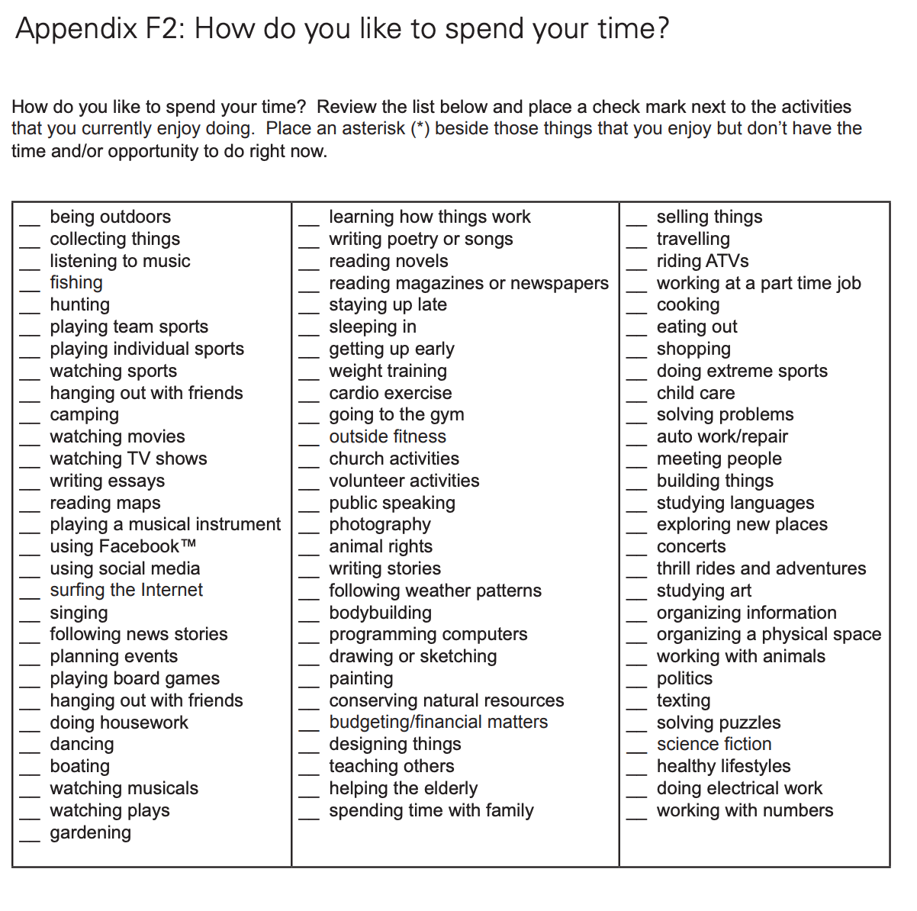

Students will use their selection focus to support the development of their individual SMART goals. Here is a worksheet to help you get started: [SMART Goal Worksheet](https://www.dukeofed.org/wp-content/uploads/2024/08/Smart-Goals-Worksheet-1.pdf)